**Department of Data Science, Bishop Heber College Tiruchirappalli**

**Modern Database Systems Lab 11**

### NAME: PAVITHIRAN .V

### ROLL NO : 235229122

Question 1

> db.students.find({"name.first":"Sam", year:1995});

{ "_id" : "sam", "name" : { "first" : "Sam", "last" : "Peter" }, "year" : 1995, "courses" : [ "php", "python", "java" ] }

Screenshot 2023-09-23 at 10.15.09 AM

Question 2

Find coureses delivered by john peter

Note that the order of fields for first and last names can be arbitrary

db.courses.find({

$or: [

{ "professor.first": "John", "professor.last": "Peter" },

{ "professor.first": "Peter", "professor.last": "John" }

]

});

{ "_id" : "php", "title" : "PHP Programming", "year" : 2007, "professor" : { "first" : "John", "last" : "Peter" }, "rating" : 53, "students" : [ "arun", "sam", "sylvia", "divya", "hazel" ], "departments" : [ "cs", "ca" ], "campus" : [ "Tricy", "Singapore" ] }



Question 3:

Find students with first name Sam who take the course php

Return names of these students only

db.students.find({

"name.first": "Sam",

courses: "php"

}, {

"name": 1,

"_id": 0

});

{ "name" : { "first" : "Sam", "last" : "Peter" } }

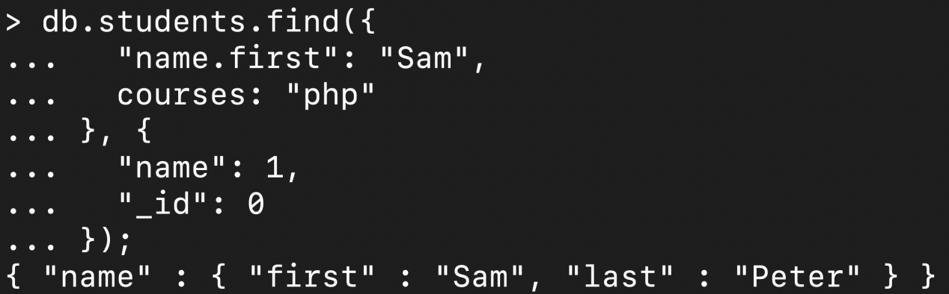

Question 4:

Find courese delivered between years 2000 and 2005 such that they have a professor specified

Return course identifier only

Order the result by ratings in descending order and then by years in ascending order

db.courses.find({

year: { $gte: 2000, $lte: 2005 },

"professor": { $exists: true }

}, {

"_id": 1

}).sort({

"rating": -1,

"year": 1

});

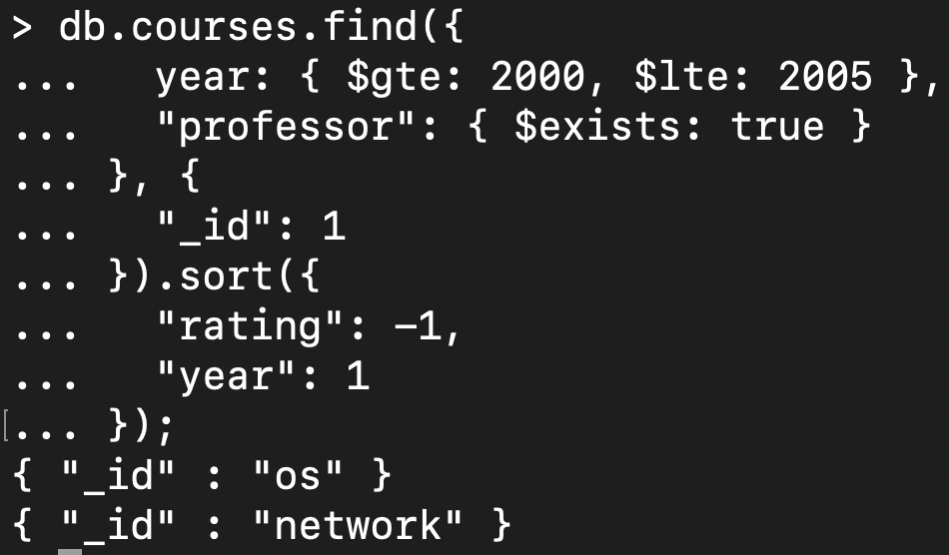

Question 5

Find students who studied courses, java, or php

Return student identifier only

Propose two different approaches

db.students.find({

courses: { $in: ["java", "php"] }

}, {

"_id": 1

});

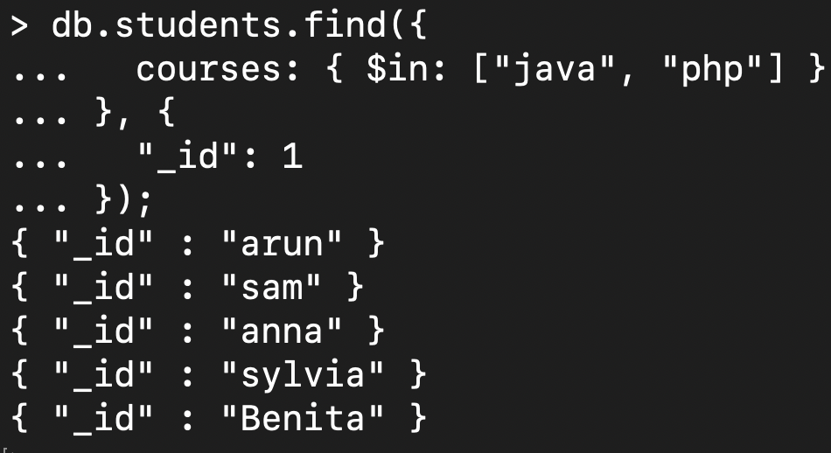

db.students.find({

$or: [

{ courses: "java" },

{ courses: "php" }

]

}, {

"_id": 1

});

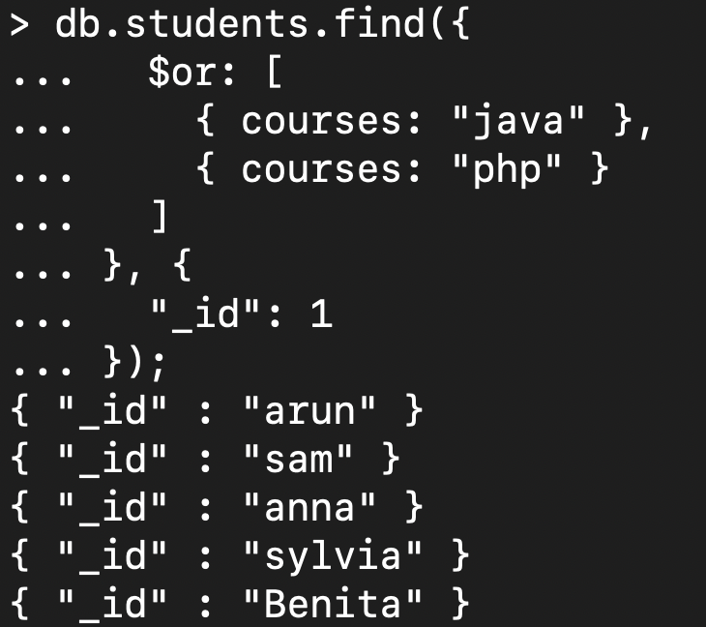

Question 6

Find students who studied courses both java and php

Return student identifier only

Propose two different approaches

db.students.aggregate([

{

$match: {

courses: { $all: ["java", "php"] }

}

},

{

$project: {

_id: 1

}

}

]);

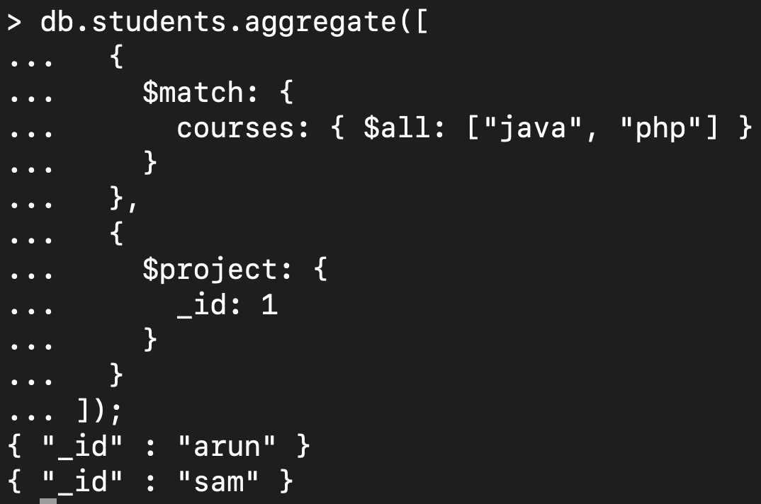

db.students.find({

courses: "java"

}, {

"_id": 1

}).toArray().filter(student => {

return db.students.findOne({

_id: student._id,

courses: "php"

});

});

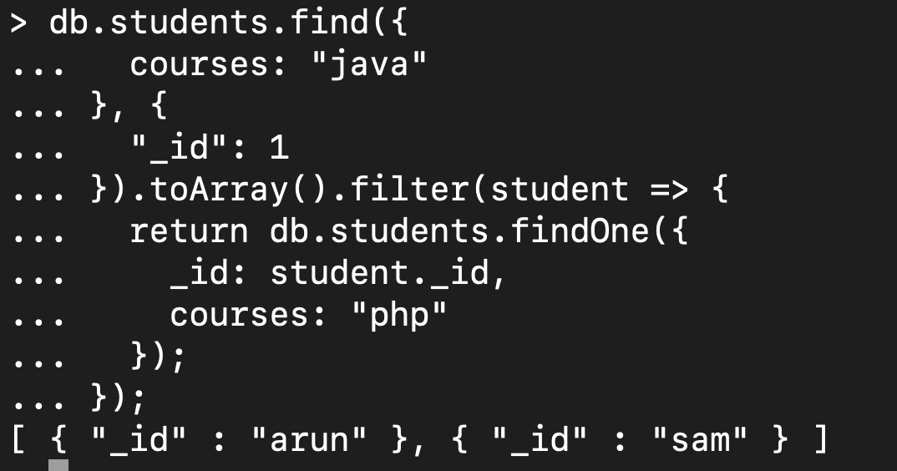

Question 7

Find courses with Tamil title equal to Python Programming

Return course title only

Note that there are two ways how course titles are defined

db.courses.aggregate([

{

$match: {

$or: [

{ "title.tamil": "Python Programming" },

{ "title.en": "Python Programming" }

]

}

},

{

$project: {

_id: 0,

title: 1

}

}

]);

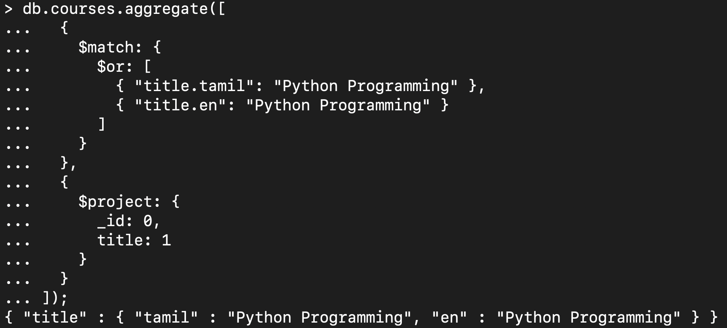

Question 8:

Find courses that have a National award from 2005

Return course identifier and all awards

db.courses.find({

"awards.type": "National Award",

"awards.year": 2005

}, {

"_id": 1,

"awards": 1

});

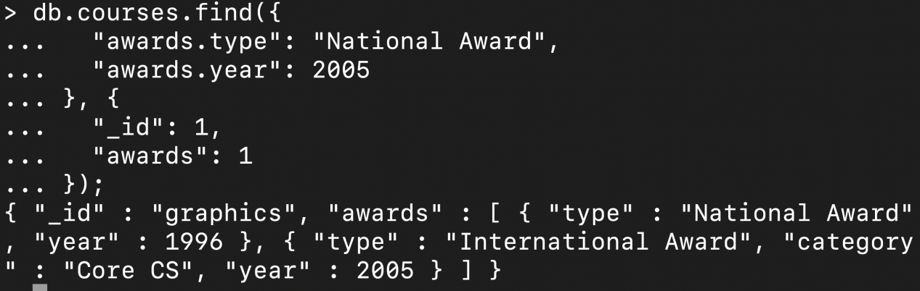

Question 9

Find courses that are offered in cs and ca departments at the same time or have a rating 80 or more

Return course identifier and at most 2 campuses

db.courses.find({

$or: [

{

departments: { $all: ["cs", "ca"] }

},

{

rating: { $gte: 80 }

}

]

},

{

"_id": 1,

"campus": { $slice: 2 }

});

